From: M. Mohsin Chowdhury <mms221@gmail.com>
Sent: 6 November, 2026 4:14 PM
To: 'Usama Iqbal' <usama.iqbal@aku.edu>
Subject: RE: Revisional Surgery After OAGB for Persistent Bile Reflux, Recurrent Anastomotic Ulceration, and Severe Hiatal Hernia

Friday, 6 November, 2026

Dear Dr Usama,

To make the best use of your time, I am sharing in advance a second surgical opinion I have received, together with a few questions I would like to discuss. I am happy to go through them with you during the call. I have done all the lab tests as you recommended, all are in normal parameters. If you want to see the reports, I can share these with you.

I appreciate your point on 22 October that email is not the ideal medium for a medical consultation. As a patient without a medical background, however, I find written explanations much easier to follow: they allow me to look up unfamiliar terms and understand your advice properly. I would therefore be grateful if, after the call, you could send me a brief written summary of your recommendations and the planned procedure.

1. Alternative approach proposed by another surgeon
Another bariatric surgeon I consulted has proposed the following:

- Adhesiolysis, followed by measurement of the bowel to confirm that the biliopancreatic limb is about 150 cm and the common channel is more than 450 cm.

- Hiatal hernia repair combined with a truncal vagotomy, which he regards as the most important step in treating the marginal ulcer.

- Conversion to Roux-en-Y by dividing the afferent (biliopancreatic) limb and joining it about 40 cm below the existing gastrojejunostomy. The gastrojejunostomy itself would be kept and reinforced with circumferential sutures rather than resected.

- Closure of the mesenteric defects.
==================
- For the treatment of marginal ulcer, to reduce acid is the utmost priority. Otherwise, you need to take life long PPI. Diversion of bile and Hp eradication is related to quality of life not the treatment of MU
- Yes, if CC is long, may extent to Ry 60cm. Further extension is not needed.

  - keep the original anastomosis is for the safety and rapid recovery. Circumference suture is intend to help the ulcer healing.
  - MU is always on intestinal side which is due to acid effect. It will not bother the cutting of Afferent loop. Usually will leave a 2cm safety margin to do it.
  - No need to biopsy
  - If you wish, endoscopy F/u may be performed 3m later up to 1 y.
- LC can be performed if you have symptoms or you preferred. Usually it cause no much cost.
- Hp eradication plays little role in the treatment of MU. We can repeat examination and treatment Hp at any time.
- Colonoscopy is not related to this treatment and no need to repeat it.
- For this kind of procedure, I don’t have any complication. A complication is possible if the revision is complicated, for example, revision OAGB or RYGB to sleeve gastrectomy plus SASI bipartion. No reason for a mortality to happen, sometimes the patient need to stay 1-2 weeks in hospital for IV fluid or drainage procedure. However, in this proposal treatment without a new anastomosis, we don’t experience complication for about 30 cases in past 20 years.

2. Points on which I would value your view
How does this approach compare with your plan? In particular:

- Truncal vagotomy: Do you consider it necessary for the ulcer to heal, and what long-term side effects might it have?

- Keeping vs resecting the ulcerated anastomosis: Would the ulcer be expected to heal if the anastomosis is kept and reinforced, and what would be the next step if it did not?

- The 40 cm Roux limb: As bile reflux is one of my main problems, is 40 cm long enough to keep bile away from the pouch? What limb length would you use?

- Gallbladder: Given the small gallstones, would you advise removing the gallbladder during the same operation?

Thank you for your time and guidance. I look forward to speaking with you this afternoon.

Kind regards,

M. Mohsin Chowdhury
F6 - ABC Bay View - Road No. 3 - Khulshi Hills - Chattogram 4225 -Bangladesh

Mobile: +880-(0) 1713 048 084 - eFax: + 1-267-390 0145 - Email: mms221@gmail.com

From: M. Mohsin Chowdhury <mms221@gmail.com>
Sent: 3 November, 2026 2:00 AM
To: 'Usama Iqbal' <usama.iqbal@aku.edu>
Subject: RE: Revisional Surgery After OAGB for Persistent Bile Reflux, Recurrent Anastomotic Ulceration, and Severe Hiatal Hernia

Tuesday, 3 November, 2026

Dear Dr Usama,

Please accept my apologies for being unable to attend the scheduled tele-consultation yesterday due to unavoidable professional commitments.

I am enclosing the outstanding laboratory test reports, as recommended by you, together with an updated and consolidated summary of my medical history and all recent investigation reports for your review.

I look forward to speaking with you during our rescheduled tele-consultation on 6 November 2026. I hope the enclosed documents will provide all the necessary information to facilitate a productive discussion and help determine the appropriate next steps towards my proposed surgical treatment.

I plan to arrive in Karachi around middle of November. Please advise tentatively how many days I shall have to wait for the surgery and what medications I should continue to take and add till I reach Karachi.

Thank you for your time and understanding.

Kind regards,

M. Mohsin Chowdhury
F6 - ABC Bay View - Road No. 3 - Khulshi Hills - Chattogram 4225 -Bangladesh

Mobile: +880-(0) 1713 048 084 - eFax: + 1-267-390 0145 - Email: mms221@gmail.com

Click to view more information PS. When replying, please do not change the subject line. Thank you.

From: M. Mohsin Chowdhury <mms221@gmail.com>
Sent: 3 November, 2026 1:24 AM
To: 'clinic.appointment@aku.edu' <clinic.appointment@aku.edu>; 'AKUH Information' <akuh.information@aku.edu>; 'Coordinator Surgery' <coordinator.surgery@aku.edu>; 'Surgery Coordinators' <Surgery.Coordinators@aku.edu>
Subject: Clarification Required Regarding Additional Tele-Consultation Fee of PKR 4,000

Tuesday, 3 November, 2026

Dear Sirs,

Thank you for the notification regarding my upcoming tele-consultation with Dr. Usama Iqbal scheduled for Friday, November 6, 2026.

I am writing to request clarification regarding the payment of PKR 4,000 requested in your email (Payment ID: 1008138260). On October 22, 2026, I already made two separate payments of PKR 5,120 each. The first payment was for an anesthesia tele-consultation, and the second was specifically for a tele-consultation with Dr. Usama Iqbal.

Ref: PAT-O-2026/199713 | Ref: PAT-O-2026-199758
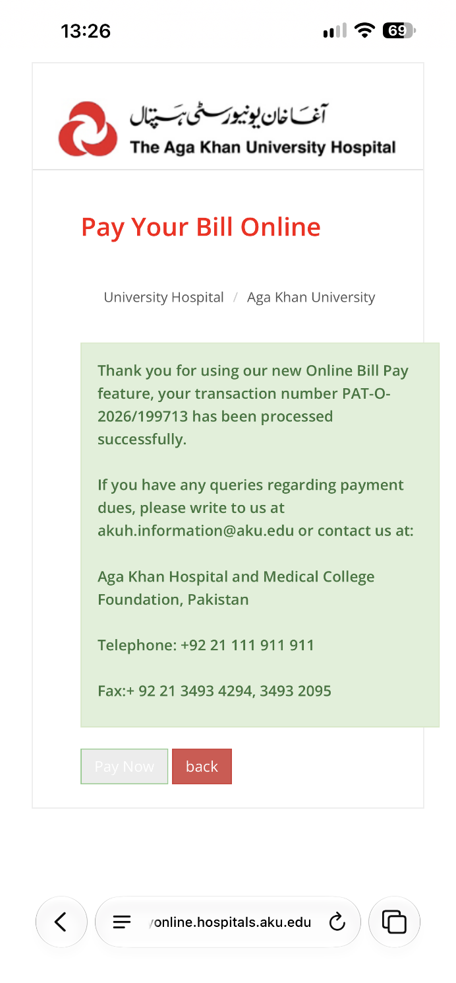 | 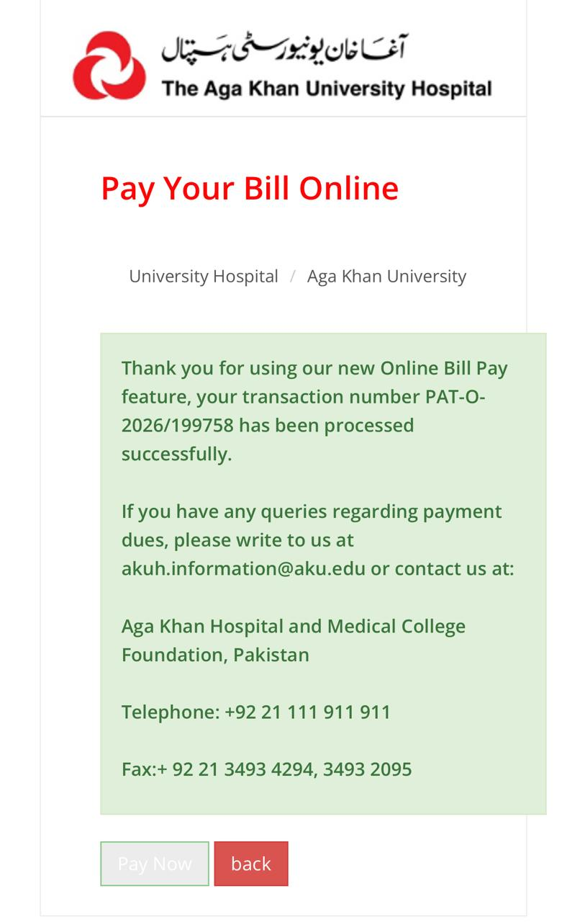

Given that I have already paid PKR 5,120 for this appointment a few days ago, could you please review my account and advise what this additional PKR 4,000 charge is for?

I would greatly appreciate it if you could clarify this billing discrepancy and confirm my appointment.

Kind regards,

M. Mohsin Chowdhury
F6 - ABC Bay View - Road No. 3 - Khulshi Hills - Chattogram 4225 -Bangladesh

Mobile: +880-(0) 1713 048 084 - eFax: + 1-267-390 0145 - Email: mms221@gmail.com

-----Original Message-----
From: clinic.appointment@aku.edu <clinic.appointment@aku.edu>
Sent: 2 November, 2026 11:29 AM
To: mms221@gmail.com
Subject: Online Payment Notification
Importance: High

Dear MOHD MOHSIN CHOUDARY,

Your appointment with Dr. Usama Iqbal has temporarily been booked at Tele-General Surgery Clinic for Friday,November 06, 2026 at 14:00. This appointment is not confirmed until FULL payment of charges Rs. 4000.

For ONLINE payment Please visit https://payonline.hospitals.aku.edu to pay by Debit/Credit Card or Telenor Easy Paisa.

For CASH payment please visit our selected Collection Points/Medical Centers. List of centers available for cash payments can be seen at https://hospitals.aku.edu/pakistan/AboutUs/News/Pages/Tele-Clinics-for-Patients.aspx under 'Pay Through Cash' button.

Please specify your MR#: 015-65-83 and Payment ID: 1008138260 at the time of making the payment.

To avoid delays or cancellation kindly pay at least 8 hours before your appointment time.

Thank You
Aga Khan University Hospital
Stadium Road, Karachi, Pakistan

From: M. Mohsin Chowdhury <mms221@gmail.com>
Sent: 1 November, 2026 1:42 AM
To: 'Usama Iqbal' <usama.iqbal@aku.edu>
Subject: RE: Revisional Surgery After OAGB for Persistent Bile Reflux, Recurrent Anastomotic Ulceration, and Severe Hiatal Hernia

Sunday, 1 November, 2026

Dear Dr Usama,

Further to our earlier communications, I would like to update you on a persistent symptom and the related investigations.

For the past 2–3 years I have experienced marked cold sensitivity. Even in an air-conditioned room maintained at 28 °C I feel uncomfortably cold.
Relevant laboratory and endoscopic findings are as follows:

- February 2025: serum ferritin was 4.55 ng/mL. Upper GI endoscopy at that time showed erosions at the stomal margin and in the adjacent stomach.
- June 2026 and September 2026: repeat endoscopies demonstrated severe marginal ulcers together with bile reflux.
- 29 September 2026: ferritin had risen only to 11.2 ng/mL.
- I subsequently received intravenous ferric carboxymaltose 500 mg on 1 October and again on 25 October 2026.

Given the history of Roux-en-Y gastric bypass and the documented marginal ulcers with bile reflux, I wonder whether impaired iron absorption has contributed to, or aggravated, the cold sensitivity. Do you expect this symptom to remain unchanged or potentially worsen after RYGB, and what longer-term management strategies would you recommend?

I shall forward the remaining medical reports to you today evening (1 November 2026) so that we can have a productive discussion during the tele-consultation scheduled for 2 November.

Thank you for your time and guidance.

Kind regards,

M. Mohsin Chowdhury
F6 - ABC Bay View - Road No. 3 - Khulshi Hills - Chattogram 4225 -Bangladesh

Mobile: +880-(0) 1713 048 084 - eFax: + 1-267-390 0145 - Email: mms221@gmail.com

From: Usama Iqbal <usama.iqbal@aku.edu>
Sent: 22 October, 2026 2:55 PM
To: Coordinator Surgery <coordinator.surgery@aku.edu>; M. Mohsin Chowdhury <mms221@gmail.com>; Aleha Asif Syed <aleha.asif@aku.edu>
Cc: Surgery Coordinators <Surgery.Coordinators@aku.edu>; Rehan Khan <Rehan.Khan@aku.edu>
Subject: RE: Revisional Surgery After OAGB for Persistent Bile Reflux, Recurrent Anastomotic Ulceration, and Severe Hiatal Hernia

Dear Mohsin,

I have already shared the list of tests to be performed. I have already reviewed your summary. It is best that we do not go through the same questions repeatedly. Please see my first response which is detailed. The next step is to get the tests done and get an appointment for anaesthesia clinic for your fitness and my clinic for a discussion on the procedure and booking. Both can not be done without a consultation.

Dear Nadia,

He doesn’t need the tests to be sent to us. Anaesthesiologist and I will review them during our teleclinic. Just give him the appointments when he asks for.

Thanks

Dr. Usama

From: Coordinator Surgery <coordinator.surgery@aku.edu>
Sent: Thursday, 22 October 2026 1:43 pm
To: M. Mohsin Chowdhury <mms221@gmail.com>; Aleha Asif Syed <aleha.asif@aku.edu>
Cc: Usama Iqbal <usama.iqbal@aku.edu>; Surgery Coordinators <Surgery.Coordinators@aku.edu>; Syed Umer Arif <umer.arif@aku.edu>; Umaima Asif Salehjee <umaima.salehjee@aku.edu>; Rehan Khan <Rehan.Khan@aku.edu>
Subject: RE: Revisional Surgery After OAGB for Persistent Bile Reflux, Recurrent Anastomotic Ulceration, and Severe Hiatal Hernia

Dear Mr. Mohsin/Dr Aleha,
As recommended by Dr. Usama, you are required to undergo the following investigations. Kindly note that we need recent reports, as reports from two years ago or even a few months ago may not be acceptable for the current assessment.
Required Investigations:
- Complete Blood Count (CBC)
- Serum Albumin
- Liver Function Tests (LFTs)
- Urea and Creatinine
- Serum Electrolytes
- HbA1c
- Serum Iron and TIBC
- Vitamin B12
- Vitamin D3
- TSH
- Fasting Lipid Profile
Kindly share the updated reports in soft copy via WhatsApp or email. Once I receive your reports, I will schedule your tele-anesthesia consultation, during which the anesthetist will review your reports and assess your fitness for surgery.
If you have already completed these investigations, please share the latest available reports so I can arrange your appointment accordingly.
Dear Dr. Aleha,
Kindly review his HTML file and share your recommendations for further management.
Thank you for your cooperation.
Kind regards,
Nadia Sultan Waseem
Coordinator, Department of Surgery

From: M. Mohsin Chowdhury <mms221@gmail.com>
Sent: Thursday, October 22, 2026 12:52 PM
To: Coordinator Surgery <coordinator.surgery@aku.edu>
Cc: Usama Iqbal <usama.iqbal@aku.edu>; Surgery Coordinators <Surgery.Coordinators@aku.edu>; Syed Umer Arif <umer.arif@aku.edu>; Umaima Asif Salehjee <umaima.salehjee@aku.edu>; Aleha Asif Syed <aleha.asif@aku.edu>; Rehan Khan <Rehan.Khan@aku.edu>
Subject: Re: Revisional Surgery After OAGB for Persistent Bile Reflux, Recurrent Anastomotic Ulceration, and Severe Hiatal Hernia

Dear Ms Nadia,

Please refer to my medical records in html file where all the recent and last two years test reports are consolidated; this file I have sent last night. Based on that, if the doctors recommend any further tests to evaluate my condition, I can do it now only and get the results to be OK (if there is any deficiency somewhere) with any recommended treatment in order not to wait until 2 November. I do not wish to waste time, and want to get my surgery done as soon as possible.

I look forward to hearing from you.

Kind regards,
M Mohsin Chowdhury
Tel: +8801713048084
Sent from mobile device; please excuse my brevity.

From: M. Mohsin Chowdhury <mms221@gmail.com>
Sent: 22 October, 2026 1:30 PM
To: clinic.appointment@aku.edu
Cc: AKUH Information <akuh.information@aku.edu>
Subject: Re: Online Payment Notification

Dear Ma’am,

Please find below my payment details. I see the my email to clinic.appointment@aku.edu was not delivered earlier.

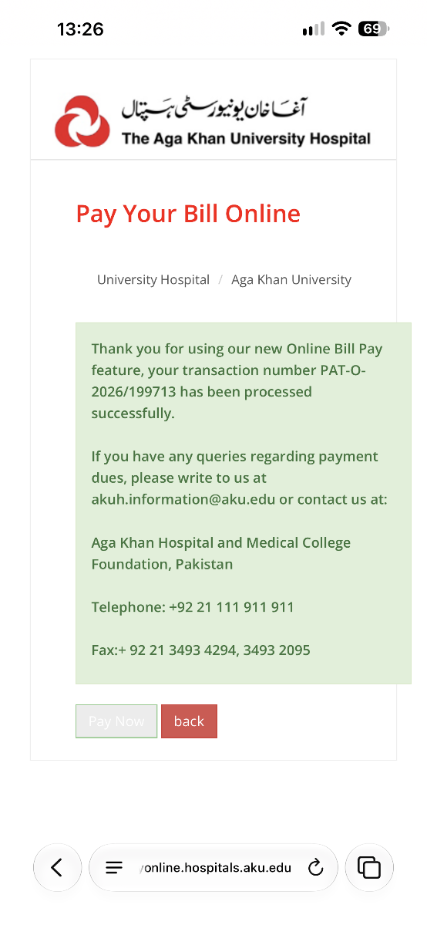
Thank you
M Mohsin Chowdhury
MMS Consortium
Tel: +8801713048084
Sent from mobile device; please excuse my brevity.

On Thu, Oct 22, 2026 at 13:19 M. Mohsin Chowdhury <mms221@gmail.com> wrote:
Dear Ma’am,

Thank you for your email and phone call.

I have a medical report from Dr A B Sonawalla where I found the MR#. I also have the plastic card somewhere in my home. I have to search intensively to find it. I preserved it as a souvenir! Unfortunately I may not be able to confirm the Payment ID. Cannot you find it under my name or MR# in your records?

Kind regards,

M Mohsin Chowdhury
Tel: +8801713048084
Sent from mobile device; please excuse my brevity.

On Thu, Oct 22, 2026 at 12:03 clinic.appointment@aku.edu <clinic.appointment@aku.edu> wrote:
Dear MOHD MOHSIN CHOUDARY,
Your appointment with Dr. Usama Iqbal has temporarily been booked at Tele-General Surgery Clinic for Monday,November 02, 2026 at 14:00. This appointment is not confirmed until FULL payment of charges Rs. 5000.
For ONLINE payment Please visit https://payonline.hospitals.aku.edu to pay by Debit/Credit Card or Telenor Easy Paisa.
For CASH payment please visit our selected Collection Points/Medical Centers. List of centers available for cash payments can be seen at https://hospitals.aku.edu/pakistan/AboutUs/News/Pages/Tele-Clinics-for-Patients.aspx under 'Pay Through Cash' button.
Please specify your MR#: 015-65-83 and Payment ID: 1008085650 at the time of making the payment.
To avoid delays or cancellation kindly pay at least 8 hours before your appointment time.
Thank You
Aga Khan University Hospital
Stadium Road, Karachi, Pakistan

On Thu, Oct 22, 2026 at 12:02 Coordinator Surgery <coordinator.surgery@aku.edu> wrote:
Dear Sir,

Thank you for your email.

Your tele-consultation appointment has been scheduled for Monday, 2 November 2026. The payment link has been sent to you via email. Please note that the consultation will be conducted via WhatsApp on your registered WhatsApp number.

Unfortunately, we are unable to schedule your appointment for this week, as the doctor is currently on leave. Therefore, your appointment has been scheduled for the coming Monday.

If you have any further queries or require assistance, please feel free to contact me on the Surgery Hotline at 0301-1100732.

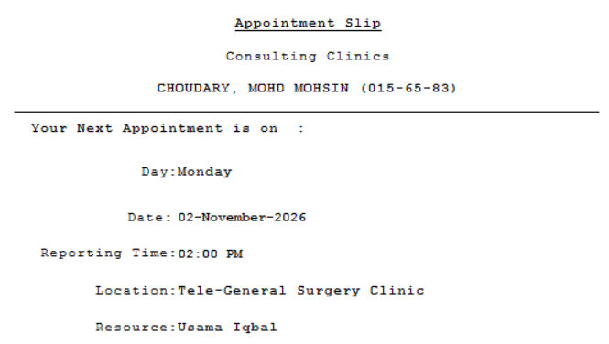

Kind regards,
Nadia Sultan Waseem
Surgery Coordinator
Department of Surgery
Aga Khan University Hospital

From: M. Mohsin Chowdhury <mms221@gmail.com>
Sent: Thursday, October 22, 2026 4:08 AM
To: Coordinator Surgery <coordinator.surgery@aku.edu>; Aleha Asif Syed <aleha.asif@aku.edu>; Rehan Khan <Rehan.Khan@aku.edu>
Cc: Usama Iqbal <usama.iqbal@aku.edu>; Syed Umer Arif <umer.arif@aku.edu>; Umaima Asif Salehjee <umaima.salehjee@aku.edu>; Surgery Coordinators <Surgery.Coordinators@aku.edu>
Subject: RE: Revisional Surgery After OAGB for Persistent Bile Reflux, Recurrent Anastomotic Ulceration, and Severe Hiatal Hernia

Thursday, 22 October, 2026

Dear Sirs,

Thank you for your email.

I already have a MRN registered with your hospital. It is 15-65-83, dated January 1990.

I have answered your queries in red fonts below.

Please advise how to pay tele-clinic consultation fee PKR 5,150.

I have also attached a consolidated summary of my laboratory results, OAGB and other Hospital Discharge reports for your review in a .html file with this email. Further, on 1 October 2026 and on 17 October 2026, I received an IV infusion of Ferric Carboxymaltose (500 mg/10 ml) to increase my Serum Ferritin level on doctor’s advice.

You can propose me a suitable time for tele-consultation, preferably 4/5 hours in advance.

I look forward to hearing from you.

Kind regards,

M. Mohsin Chowdhury
F6 - ABC Bay View - Road No. 3 - Khulshi Hills - Chattogram 4225 -Bangladesh

Mobile: +880-(0) 1713 048 084 - eFax: + 1-267-390 0145 - Email: mms221@gmail.com

Click to view more information PS. When replying, please do not change the subject line. Thank you.

From: Usama Iqbal <usama.iqbal@aku.edu>
Sent: 22 October, 2026 1:07 PM
To: mms221@gmail.com
Cc: Rehan Khan <Rehan.Khan@aku.edu>; Surgery Coordinators <Surgery.Coordinators@aku.edu>; Coordinator Surgery <coordinator.surgery@aku.edu>; Aleha Asif Syed <aleha.asif@aku.edu>
Subject: RE: Revisional Surgery After OAGB for Persistent Bile Reflux, Recurrent Anastomotic Ulceration, and Severe Hiatal Hernia

Dear Mohsin,

- Yes, resection of the old anastomosis and creation of a new one will be done.
- We use Covidien (Medtronic) Tristaple (USA) items only, including guns, reloads, trocars, energy devices, etc.
- I will be doing the procedure myself with my fellow and residents. I am the primary bariatric and upper GI surgeon at AKU.
- I have already shared my personal experience with primary and revision bariatric and hiatus hernia surgery. These are the case I have done myself.

I would recommend that we discuss face to face during the tele consultation regarding any other medical/surgical queries. This helps to clarify the management plan. You can write down your questions to be discussed during the teleclinic. E-mail is not the best way of medical consultation and may create confusions.

Thanks

Dr. Usama Iqbal

From: M. Mohsin Chowdhury <mms221@gmail.com>
Sent: Thursday, 22 October 2026 4:19 am
To: Usama Iqbal <usama.iqbal@aku.edu>
Cc: Syed Umer Arif <umer.arif@aku.edu>; Umaima Asif Salehjee <umaima.salehjee@aku.edu>; Rehan Khan <Rehan.Khan@aku.edu>; Surgery Coordinators <Surgery.Coordinators@aku.edu>; Coordinator Surgery <coordinator.surgery@aku.edu>; Aleha Asif Syed <aleha.asif@aku.edu>
Subject: RE: Revisional Surgery After OAGB for Persistent Bile Reflux, Recurrent Anastomotic Ulceration, and Severe Hiatal Hernia

Thursday, 22 October, 2026

Dear Dr Usama,

I would be grateful if you could answer my following queries:

- Will you remove my ulcerated Anastomosis and create a new one for RYGB?

- Please advise the model, manufacturer, and country of manufacture of the stapler and cartridge/reload products used in your hospital for bariatric surgeries, including any third-party reloads or staple-line reinforcement materials, if used.

- Who will be assisting you as a second bariatric surgeon during the operation?

- How many OAGB to RYGB conversion have you done yourself as a principal bariatric surgeon?

Kind regards,

M. Mohsin Chowdhury
F6 - ABC Bay View - Road No. 3 - Khulshi Hills - Chattogram 4225 -Bangladesh

Mobile: +880-(0) 1713 048 084 - eFax: + 1-267-390 0145 - Email: mms221@gmail.com

Click to view more information PS. When replying, please do not change the subject line. Thank you.

From: Rehan Khan <Rehan.Khan@aku.edu>
Sent: 16 October, 2026 12:36 PM
To: Usama Iqbal <usama.iqbal@aku.edu>; Coordinator Surgery <coordinator.surgery@aku.edu>; mms221@gmail.com; Aleha Asif Syed <aleha.asif@aku.edu>
Cc: Surgery Coordinators <Surgery.Coordinators@aku.edu>
Subject: RE: Revisional Surgery After OAGB for Persistent Bile Reflux, Recurrent Anastomotic Ulceration, and Severe Hiatal Hernia

Dear Team,

Find the attached Letter

From: Coordinator Surgery <coordinator.surgery@aku.edu>
Sent: 16 October, 2026 10:34 AM
To: mms221@gmail.com; Aleha Asif Syed <aleha.asif@aku.edu>; Rehan Khan <Rehan.Khan@aku.edu>
Cc: Usama Iqbal <usama.iqbal@aku.edu>; Syed Umer Arif <umer.arif@aku.edu>; Umaima Asif Salehjee <umaima.salehjee@aku.edu>; Surgery Coordinators <Surgery.Coordinators@aku.edu>
Subject: RE: Revisional Surgery After OAGB for Persistent Bile Reflux, Recurrent Anastomotic Ulceration, and Severe Hiatal Hernia

Dear Sir,

Thank you for contacting The Aga Khan University Hospital for a tele-clinic consultation.

To create your Aga Khan Medical Record Number (MRN) and schedule your appointment for the Anesthesia Clinic Tele-Consultation, kindly share the following details:

Full Name Mohammed Mohsin Chowdhury

WhatsApp/Contact Number +8801713048084

Complete Address F6 - ABC Bay View - Road No. 3 - Khulshi Hills - Chattogram 4225 -Bangladesh

Date of Birth 11 July 1967

Email Address mms221@gmail.com

The tele-clinic consultation fee is PKR 5,150.

Please find below the approximate estimated costs for cholecystectomy, hiatal hernia surgery, or gastric bypass, including a three-day hospital stay:

General Ward: PKR 1,500,000

Semi-Private Room: PKR 1,730,000

Private Room: PKR 2,050,000

Please note that these are approximate estimates and may vary depending on the patient's clinical condition, the procedure performed, and the final treatment plan.

Dear Dr. Aleha/Rehan ,

Mr. Rehan will prepare the visa invitation letter and share it with Mr. Mohsin for further processing.

Dear Mr. Mohsin,

Please feel free to contact me on WhatsApp at 0301-1100732 if you require any further assistance.

Kind regards,
Nadia Sultan Waseem
Coordinator
Department of Surgery
The Aga Khan University Hospital
Karachi, Pakistan
WhatsApp: 0301-1100732

From: Usama Iqbal <usama.iqbal@aku.edu>
Sent: 15 October, 2026 11:02 PM
To: mms221@gmail.com
Cc: Aleha Asif Syed <aleha.asif@aku.edu>; Coordinator Surgery <coordinator.surgery@aku.edu>
Subject: RE: Revisional Surgery After OAGB for Persistent Bile Reflux, Recurrent Anastomotic Ulceration, and Severe Hiatal Hernia

Dear Nadia,

Can I request you to please give Mr. Mohsin as estimate for the following procedures?
- Gastric bypass
- Hiatus hernia repair
- Cholecystectomy
Please also give him my and anesthesia teleclinic appointments. Please also arrange for him to have a visa invitation letter for himself and his wife.

Dear Mohsin,

I don’t think itemized bill is possible at this stage. All we can tell you is an ESTIMATE of the procedural and admission cost (including the inpatient expenses only). This can vary sometimes but not to a great extent. I don’t think we can identify an accommodation for you, but Nadia can guide you better. You can choose any nearby hotel/guest house of which there are quite a few around.

Thanks

Dr Usama

From: M. Mohsin Chowdhury <mms221@gmail.com>
Sent: 15 October, 2026 8:12 PM
To: 'Usama Iqbal' <usama.iqbal@aku.edu>
Cc: 'Aleha Asif Syed' <aleha.asif@aku.edu>; 'Coordinator Surgery' <coordinator.surgery@aku.edu>
Subject: RE: Revisional Surgery After OAGB for Persistent Bile Reflux, Recurrent Anastomotic Ulceration, and Severe Hiatal Hernia

Thursday, 15 October, 2026

Dear Dr. Usama Iqbal,

Thank you for your detailed and informative email.

I completed several additional tests two days ago and have attached the reports, along with a consolidated summary of my laboratory results, for your review. My folate result is still pending and is expected within the next few days.

Please let me know whether any further tests should be completed in Bangladesh before I travel to Karachi.

I would also be grateful if Aga Khan University Hospital could issue a medical visa invitation letter for both me, as the patient, and my wife, who will accompany me. I have attached copies of our passports. For ease of reference, the details are below:

Patient
Mohammed Mohsin Chowdhury
Passport number A03827176
Date of issue 09 May 2022
Date of expiry 08 May 2032
Date of Birth 11 July 1967

Accompanying wife
Karimunnessa Shefa Chowdhury
Passport number A20099846
Date of issue 08 September 2025
Date of expiry 07 September 2035
Date of Birth 15 April 1976

I am available for a teleclinic appointment at your convenience. Please let me know the proposed time a few hours in advance, if possible.

I would appreciate any assistance from the hospital’s patient services team in identifying suitable accommodation or nearby hotels for our stay.

Finally, for financial planning, I would be grateful for an itemized estimated cost of treatment at Aga Khan University Hospital, including the gastric bypass revision, hiatal hernia repair, cholecystectomy, and any related hospital, professional, anaesthesia, investigation, or other applicable charges.

Please let me know if you require any further information or documents.

Best regards,

M. Mohsin Chowdhury
F6 - ABC Bay View - Road No. 3 - Khulshi Hills - Chattogram 4225 -Bangladesh

Mobile: +880-(0) 1713 048 084 - eFax: + 1-267-390 0145 - Email: mms221@gmail.com

Click to view more information PS. When replying, please do not change the subject line. Thank you.

From: Usama Iqbal <usama.iqbal@aku.edu>
Sent: 12 October, 2026 10:16 AM
To: mms221@gmail.com
Cc: Aleha Asif Syed <aleha.asif@aku.edu>; Coordinator Surgery <coordinator.surgery@aku.edu>
Subject: RE: Revisional Surgery After OAGB for Persistent Bile Reflux, Recurrent Anastomotic Ulceration, and Severe Hiatal Hernia

Dear Mohsin,

It appears that there are three problems here,

- Anastomotic ulcer
- Hiatus hernia
- Cholelithiasis (Gall stones)

5.1. Choice of revisional bariatric procedure

Revisional procedure is recommended in case of a persistent anastomotic ulcer. Because of the presence of bile reflux and hiatus hernia, the procedure of choice is Roux-en-Y gastric bypass.

5.2. Simultaneous versus staged surgical procedures

Simultaneous repair of hiatus hernia, performance of Roux-en-Y gastric bypass and cholecystectomy is recommended. In case of any gastric bypass, cholecystectomy is recommended for cholelithiasis as it is very difficult to treat the associated complications if they happen.

5.3. Persistent H. pylori infection and ulcer management

A persistent ulcer is more likely to be due to bile reflux and ischemia. Therefore, revisional surgery is recommended. However, H. pylori will still need long-term treatment by a gastroenterologist which can happen after the operation.

5.4. Experience with revisional OAGB surgery

We have performed about 30 revisional procedures which include

- Gastric band revisions
- Gastric sleeve revisions
- MGB/OAGB revisions
- Roux-en-Y gastric bypass revisions

All have been successful laparoscopically with no complications. Additionally, our center routinely performs hiatus hernia repair. We perform approximately 25 cases per year.

5.5. Preoperative investigations and surgical fitness

I think you have been extensively investigated already. I would like to have the following tests done.

- Full blood counts
- Albumin
- Liver function tests
- Urea, creatinine
- Serum electrolytes
- HbA1c
- Serum iron and TIBC
- Serum vit B12
- Serum Vit D3
- TSH
- Fating lipid profile

Additionally, you will need to do a teleclinic appointment with me and anesthesiologist for preoperative fitness with these blood test results. Please call AKU no. for appointments or just reply to this email for appointments. I am keeping our clinical coordinator in cc.

5.6. Estimated treatment costs

I would request our clinical coordinator for an estimated cost for the following procedures

- Gastric Bypass
- Hiatus hernia repair
- Cholecystectomy

5.7. Duration of hospitalization and stay abroad

Duration of hospitalization will be 1-2 days. I would recommend you stay for 1-2 weeks in Pakistan depending on your progress.

Thanks

Dr. Usama Iqbal
Upper GI Surgeon
AKU

From: M. Mohsin Chowdhury <mms221@gmail.com>
Sent: Monday, 12 October 2026 12:45 am
To: Usama Iqbal <usama.iqbal@aku.edu>
Subject: Revisional Surgery After OAGB for Persistent Bile Reflux, Recurrent Anastomotic Ulceration, and Severe Hiatal Hernia

Monday, 12 October, 2026

Dr. Usama Iqbal
Usama.Iqbal@aku.edu

Dear Doctor,

I am writing to seek your expert opinion and possible surgical treatment for persistent gastrointestinal complications following a One-Anastomosis Gastric Bypass (OAGB / Mini-Gastric Bypass) performed on 4 July 2017 at Apollo Hospitals, Bangalore, India.

For approximately two years, I have been experiencing recurrent gastrointestinal problems, including chronic ulceration near the gastrojejunal anastomosis, Helicobacter pylori infection, and significant bile reflux. Despite medical treatment, these problems have persisted, culminating in an episode of gastrointestinal bleeding and hospitalisation in September 2026.

I have been advised to consider reversal of my original OAGB or conversion to a Roux-en-Y Gastric Bypass (RYGB), together with hiatal hernia repair and gallbladder removal.
Before proceeding, I would greatly appreciate your independent assessment and recommendations regarding the most appropriate treatment strategy.

1. Recent Treatment History and Clinical Developments

First H. pylori Eradication Regimen — June 2026
On 6 June 2026, my treating physician prescribed a vonoprazan-based dual therapy regimen for H. pylori infection, together with sucralfate for ulcer management:
- Vonoprazan 20 mg: Twice daily for two months.
- Amoxicillin 1,000 mg: Three times daily for 14 days.
- Sucralfate 1 g: As prescribed, for two months.

I followed the prescribed treatment and continued taking vonoprazan and sucralfate until 30 August 2026.

I subsequently discontinued these medications, intending to observe a 15-day medication-free interval before undergoing an H. pylori eradication confirmation test. Unfortunately, during this planned interval, I experienced a syncopal/presyncopal episode and required hospitalisation.

Hospitalisation and Repeat Endoscopy — September 2026
On 8 September 2026, I was admitted to Apollo Imperial Hospitals, Chattogram, following an episode of fainting or near-fainting associated with a fall. I had also been passing dark, bloody stools (melena), with a suspected fall in blood pressure contributing to the episode.
Neurological and cardiovascular investigations, including Brain MRI, EEG, Carotid Colour Doppler Ultrasound, and Transthoracic 2D Echocardiography, reportedly did not identify any significant alternative cause.

A repeat upper gastrointestinal endoscopy performed on 9 September 2026 revealed:
- A large chronic ulcer immediately below the gastrojejunal anastomotic margin, described in the report as a chronic duodenal ulcer.
- Significant bile accumulation and bile reflux disease.
- Hiatal hernia (Hill Grade IV).
- A persistently positive Rapid Urease Test (RUT) for H. pylori.

These findings were particularly concerning because chronic ulceration and H. pylori positivity had also been documented during my June 2026 endoscopy, despite the treatment undertaken subsequently.

Second H. pylori Eradication Regimen — September 2026
Following the September endoscopy, my treating physician prescribed a levofloxacin-based triple therapy regimen, together with continued ulcer treatment:
- Amoxicillin 1,000 mg: Three times daily for 14 days.
- Levofloxacin 500 mg: Once daily.
- Dexlansoprazole 30 mg: Twice daily for three months, as originally prescribed.
- Sucralfate 1 g: Four times daily for two months.

Current Medical Treatment

At present, I am taking Dexlansoprazole 30 mg three times daily and Sucralfate 1 g four times daily for management of my gastrointestinal symptoms.

Given the persistence of ulceration and positive H. pylori findings despite the earlier treatment, I am concerned about the possibility of recurrent or further gastrointestinal bleeding and the long-term effectiveness of medical management alone.

I would therefore welcome your opinion on whether the underlying post-OAGB anatomy and associated bile reflux may be contributing to these ongoing problems.

2. Other Relevant Clinical Findings
An abdominal ultrasonogram performed on 7 June 2026 revealed:
- Cholelithiasis, with multiple gallstones.
- Grade I fatty changes in the liver.
- A right renal cortical cyst with thin internal septa, reported as benign.

Earlier endoscopic examinations had also documented erosions and chronic ulceration around the gastrojejunal anastomotic region.

In view of these findings, I have been advised that three surgical interventions may need to be considered:
- OAGB revision: Either reversal of the original bypass or conversion to Roux-en-Y Gastric Bypass.
- Hiatal hernia repair.
- Cholecystectomy: Removal of the gallbladder.

3. Original Bariatric Surgery and Weight History
At the time of my OAGB in July 2017:
- Weight: 93 kg.
- BMI: Approximately 33 kg/m².

Following surgery, my weight gradually decreased to approximately 67 kg within six to eight months.

During the subsequent years, my weight remained relatively stable before gradually increasing over the past two to three years, reaching approximately 80 kg in 2025.

On the recommendation of my bariatric surgeon, I received Tirzepatide treatment for approximately four months, which reduced my weight to around 69 kg.

I discontinued Tirzepatide more than six months ago.

My present measurements are:
- Age: 59 years.
- Weight: 73 kg.
- BMI: Approximately 26 kg/m².

4. Other Relevant Medical History

I have mild hypertension, currently treated with Amlodipine 10 mg every morning.

I have also suffered from idiopathic hypersomnia since adolescence (1983) and have been taking Methylphenidate regularly since 1990, under the supervision of my neurologist.

I have never been diagnosed with diabetes.

Apart from the conditions described above, I am not aware of any other significant medical problems.

5. Questions Regarding the Proposed Surgical Treatment
I would be grateful for your expert assessment of the following:

5.1. Choice of revisional bariatric procedure
Considering my history of OAGB, persistent bile reflux, recurrent ulceration, hiatal hernia, and recent gastrointestinal bleeding, would reversal of the original OAGB or conversion to Roux-en-Y Gastric Bypass be more appropriate?

In particular, which procedure would offer the better prospect of controlling bile reflux, preventing recurrent ulceration, and maintaining adequate nutrition in the long term?

5.2. Simultaneous versus staged surgical procedures
Would it be technically feasible and medically advisable to perform the OAGB revision, hiatal hernia repair, and gallbladder removal during a single operation?

Alternatively, would a staged approach be preferable considering my recent bleeding episode and existing ulcer?

If staged surgery is recommended, which procedure should take priority, how many separate operations would be required, and what intervals would ordinarily be advisable?

5.3. Persistent H. pylori infection and ulcer management
Given that my September 2026 endoscopy remained positive for H. pylori following the earlier vonoprazan-based treatment, would further evaluation or confirmation of eradication be advisable before revisional surgery?

Would the ulcer need to be completely healed before surgery, or could revisional surgery itself form part of the definitive treatment where bile reflux is contributing to persistent ulceration?

I would also appreciate your opinion on the current medical management and whether additional investigations are necessary to clarify the cause of the recurrent ulcers.

5.4. Experience with revisional OAGB surgery
May I kindly ask approximately how many OAGB reversals and OAGB-to-RYGB conversions you or your surgical team have performed?

I would particularly appreciate information about your experience managing patients with severe bile reflux, recurrent anastomotic ulcers, and hiatal hernia following OAGB.

5.5. Preoperative investigations and surgical fitness
Considering my recent gastrointestinal bleeding, hypertension, long-term Methylphenidate use, and previous bariatric surgery, what additional preoperative investigations or specialist assessments would you recommend?

5.6. Estimated treatment costs
Could you kindly provide an approximate itemised estimate of the total treatment costs, including surgery, anaesthesia, hospitalisation, preoperative investigations, and postoperative care?

If both simultaneous and staged surgical approaches are feasible, separate cost estimates would be helpful.

5.7. Duration of hospitalisation and stay abroad
As I would be travelling from Bangladesh, approximately how many days should I expect to remain hospitalised, and how much additional time should I allocate for recovery, follow-up, and clearance for international air travel?

6. Medical Records Enclosed
For your reference, I am enclosing a consolidated PDF containing:
- Original OAGB operative records and discharge summary from Apollo Hospitals, Bangalore (July 2017).
- Upper gastrointestinal endoscopy reports from March 2025, June 2026, and September 2026.
- Colonoscopy report from March 2025.
- Abdominal ultrasonography reports from 2025 and June 2026.
- Hospital discharge summary from September 2026.

I fully understand that a definitive recommendation would require a thorough clinical assessment and possibly additional investigations. Nevertheless, your preliminary opinion would be extremely valuable in helping me understand the available options and make an informed decision about further treatment.

My principal objective is to obtain a safe and durable solution to the recurrent ulceration and bile reflux while minimising the risks of further complications and preserving my long-term nutritional status and quality of life.

I would be grateful if you could let me know whether your centre would be able to undertake the necessary evaluation and surgical treatment.

Please feel free to request any additional information, medication history, investigation results, or previous operative details you may require.

Thank you very much for your time and consideration. I look forward to receiving your expert guidance.

Kind regards,

M. Mohsin Chowdhury
F6 - ABC Bay View - Road No. 3 - Khulshi Hills - Chattogram 4225 -Bangladesh

Mobile: +880-(0) 1713 048 084 - eFax: + 1-267-390 0145 - Email: mms221@gmail.com

